October 10, 2023

Dear

The Stewardship Committee and Session thank you for your support of First United Presbyterian Church of Dale City. In conjunction with FUPCDC’s new VISION, the theme for this year’s campaign is Serving with Joy.
“As each has received a gift, use it to serve one another, as good stewards of God's varied grace.” 1 Peter 4:10

As we prepare to enter 2024, our Session continues to focus on our purpose:
WELCOMING ALL,
GROWING TOGETHER, and
SERVING WITH JOY!
The Lord continues to guide our direction. We continue to upgrade our facilities; grow our Youth and Children’s ministries; our music programs flourish. We hired a Contemporary Worship Leader, A Youth Director and a Parish Assistant. Our Pastor and Session continue to faithfully lead us in the life of this church as we commit to our future. We are blessed by an active, passionate, talented and engaged Congregation.
Our Session is committed to maintaining our sound financial base. Our budgeting strategy relies heavily on the results of the Stewardship Campaign. We recognize that the current economic environment, with high inflation, has affected us all individually and will affect the Session’s ability to support God’s work through FUPCDC. Understanding that while you may be facing unique challenges, we are asking that you prayerfully consider making your pledge for 2024. By pledging, you will allow the Session to formulate a workable budget that allows your pledged donations to work on FUPCDC Ministries. Should your financial circumstances change during the year, your level of commitment may be increased or decreased accordingly.
Your commitment is a covenant between you and God. We invite you to bring your 2024 Stewardship Commitment forward on Dedication Sunday, October 22, 2023, as a sacred offering, confirming your covenant. The commitment you bring forward in the name of Jesus Christ will be a sign that you are growing as a steward made in the image of a giving God.
An electronic pledge form for 2024 is available on the church website. You may also print a paper copy (attached) and send it to the church, ATTN: 2024 Stewardship Campaign. Our goal is for every family and individual, members, friends and non-members, to make a pledge commitment for 2024.
Thankfully in Christ,
The 2024 Stewardship Campaign Committee

“O God, we thank you for your great generosity. All that we are and all that we have is a gift from you. Help us to serve one another with joy and so reflect your spirit and goodness. Accept these pledges and offerings and grant that the causes to which they are devoted may prosper under your guidance. In Christ’s name we pray.”

2024 FUPCDC Pledge

As we celebrate our VISION as members of the FUPCDC Community of Faith, I/we make the following pledge for 2024. This pledge is a statement of intent; it can be increased or decreased as circumstances require.

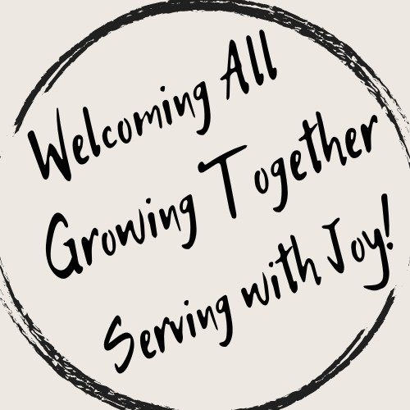

I/We wish to pledge $_______________

Per Week Month Year

__________________________________________________________________________
First & Last Name(s) of all givers included on this pledge

__________________________________________________________________________
Address
_____________________________________________________________________
Email or phone number

Do you want to receive giving envelopes? Yes No

